H803WIFI

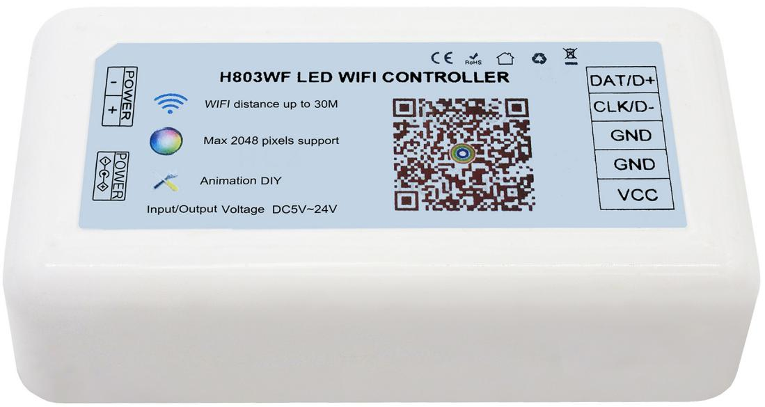

- Support Chips:
TM1812, LPD1883, UCS1903, UCS1909, UCS1912, P9883, SM16703, SM16709, SM16712, WS2811, WS2812, APA104, TM1809, TM1804, INK1003, LX1003, APA102, LPD6803, UCS6909, UCS6912, SM16716, DMX512.

- Features:
- . H803WIFI only supports android phone.
- . One phone controls one H803WIFI directly via WiFi.
- . One phone controls multiple H803WIFIs via router.
- . H803WIFI has one port, drives maximum 2048 pixels.
- . H803WIFI stores maximum 72 animation, supports color DIY, built-in many actions.
- . Input/Output Voltage: DC5V~24V.
- . H803WIFI supports Art-Net protocol.
- . You can change name and password of each device at WiFi connection interface with your phone.

3. Manual
Step1. Install App
App download link:
https://drive.google.com/open?id=11TNxYoFvcqZ12PdqpbVRZ-j41uYYjXzo
Or you can scan the QR code on H803WIFI
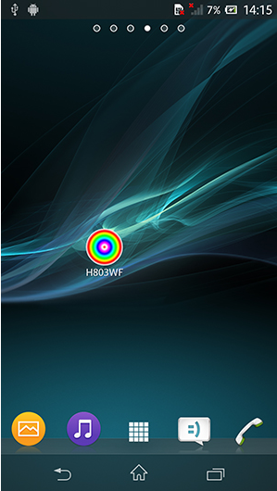

Step2. Assume you have a 16x16 (pixels) WS2812B screen, connect it to H803WIFI

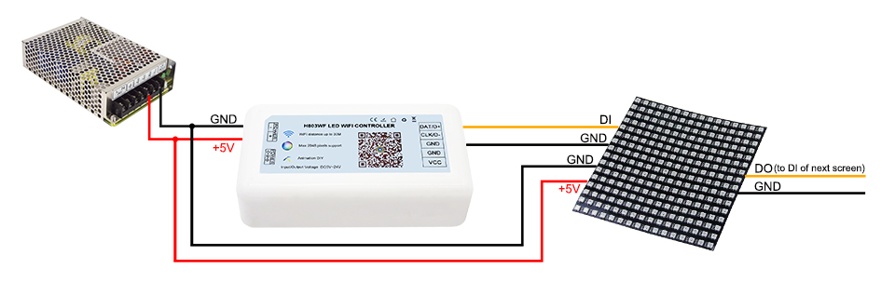

Note: Though H803WIFI can provide power for screen, when input voltage is 5V, max output power is 5V x 4A= 20W.

To make sure screen works fine, sometimes you have to output the power from power supply or add an extra power supply for screen, same for strip or other lights.

Step3. Program in App

(1). Turn on WiFi in your phone

(2). Open H803WF.apk

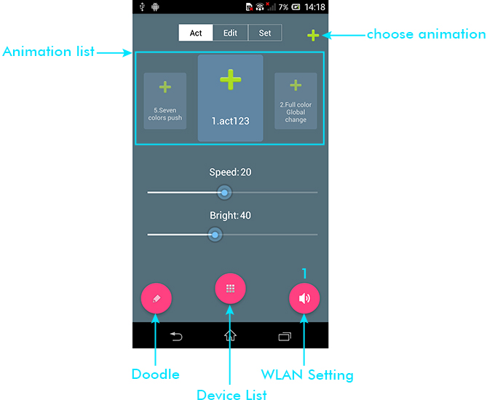

Controller name starts with "HCX", no password, select it and connect phone to controller

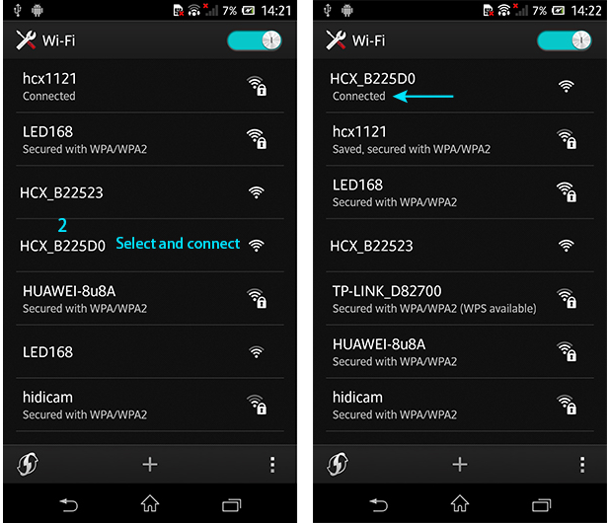

Back to App
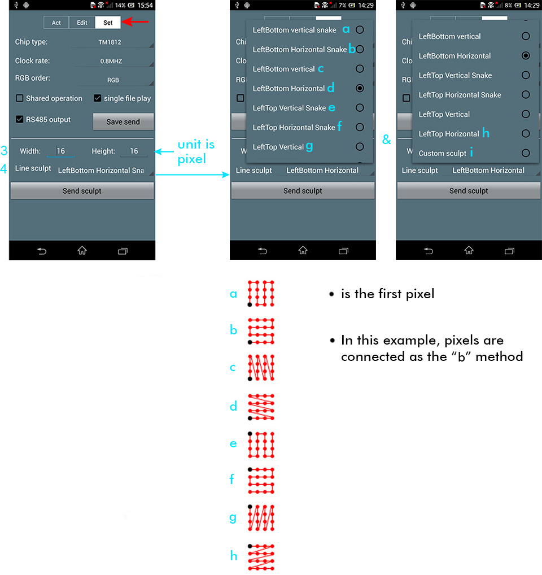

If none of the connection method fits your real connection, choose "Custom sculpt", then click "Edit sculpt"

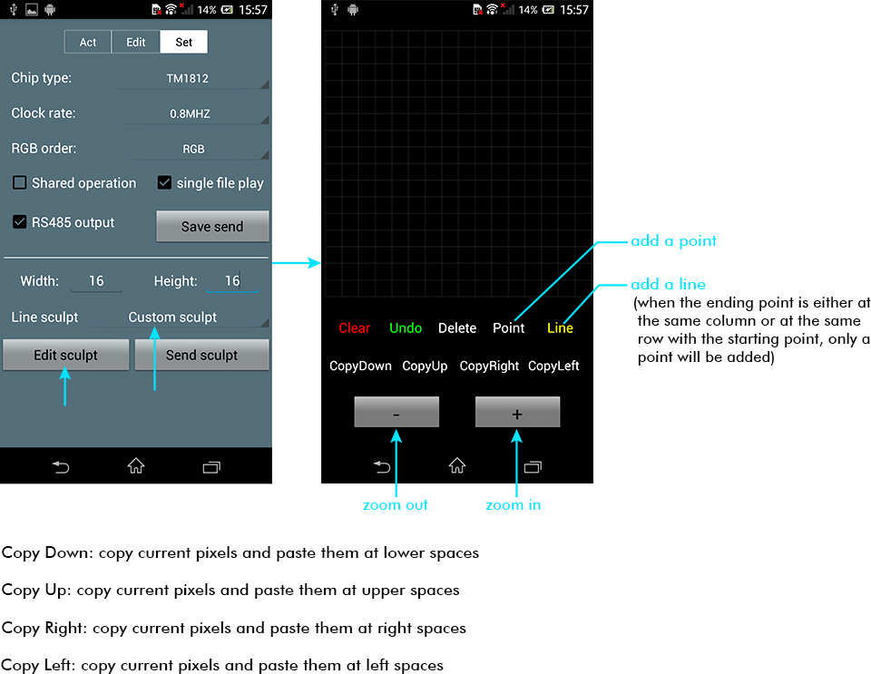

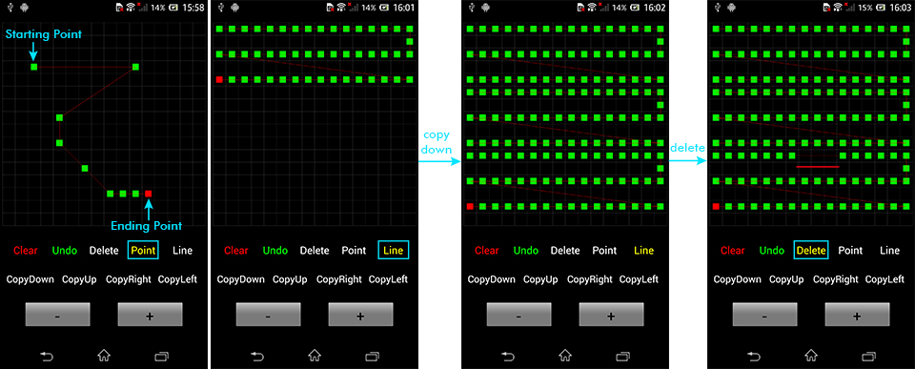

Then, click "Send sculpt"

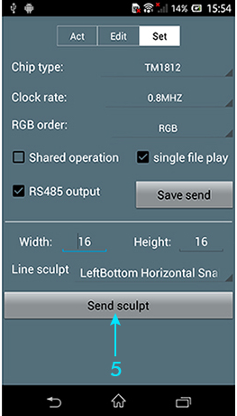

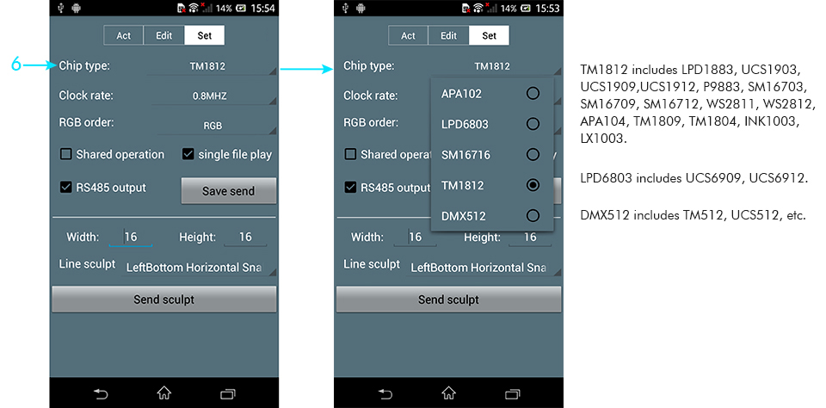

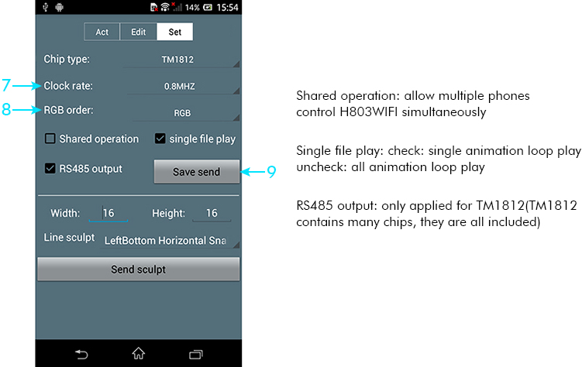

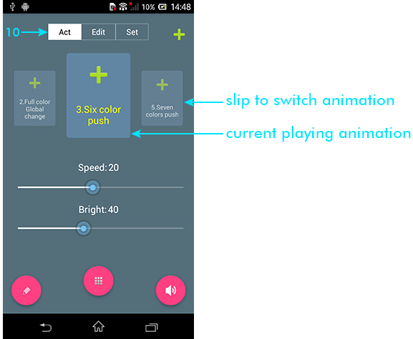

By now, you should be able to control lights with H803WIFI. However, H803WIFI can do more

(1). Edit animation

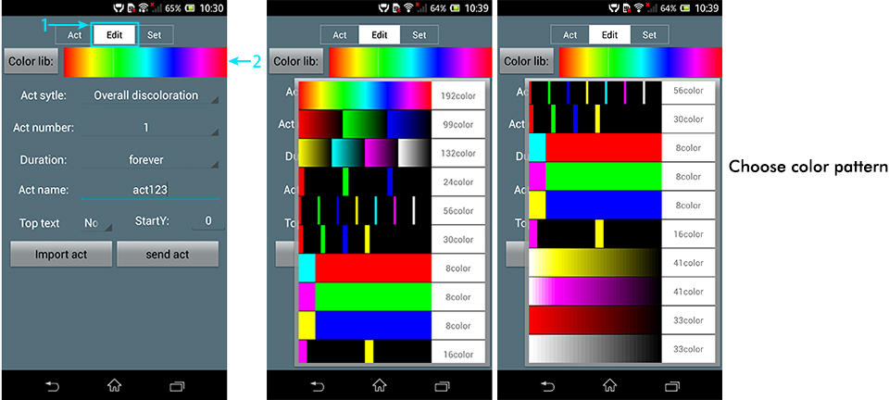

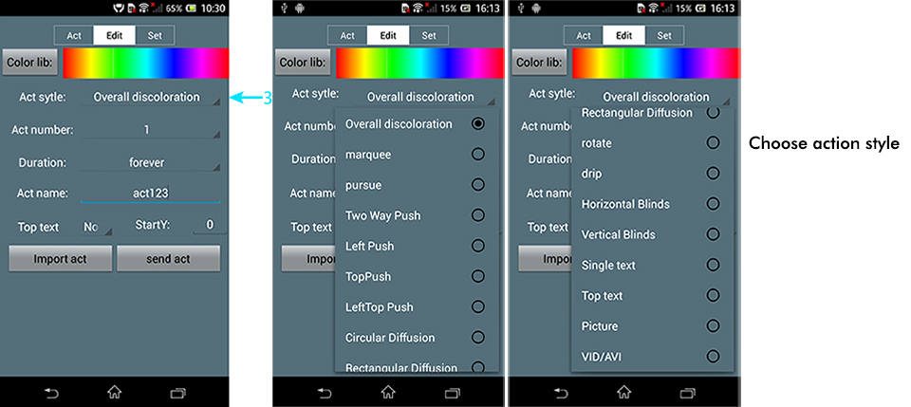

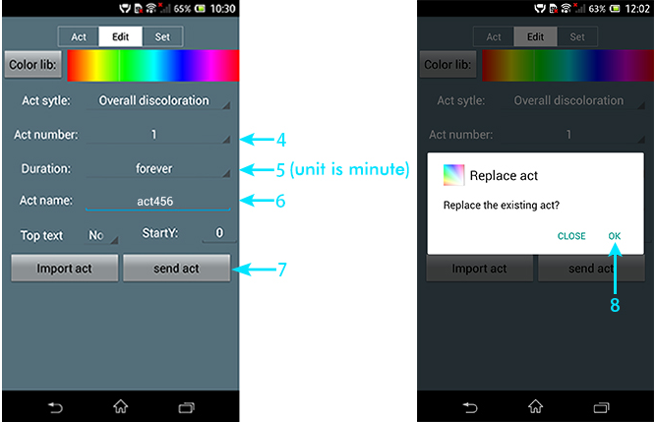

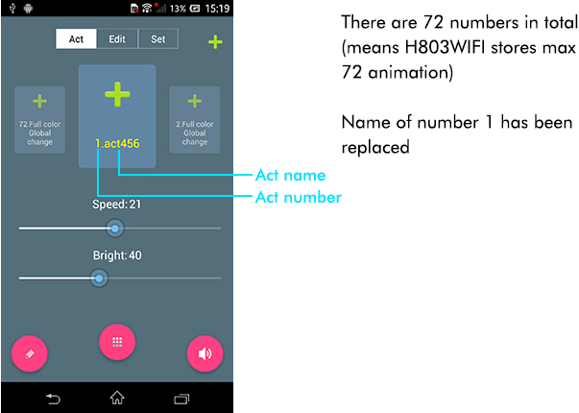

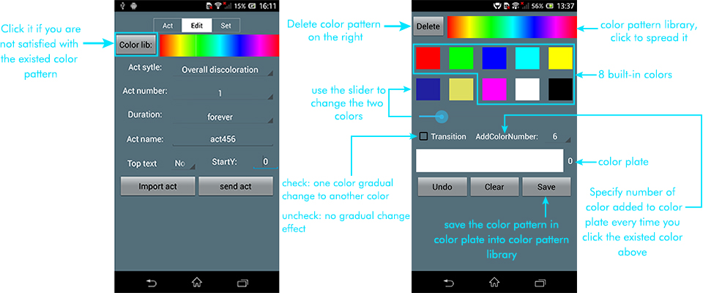

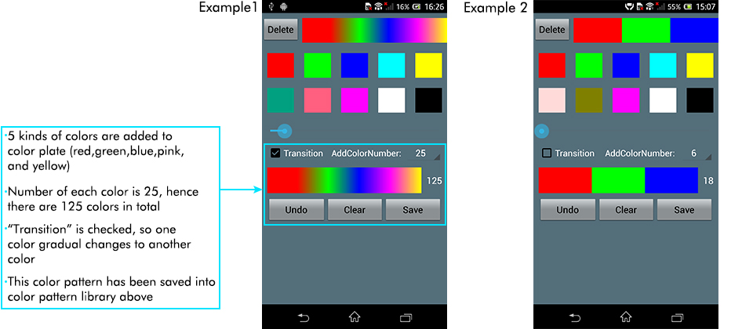

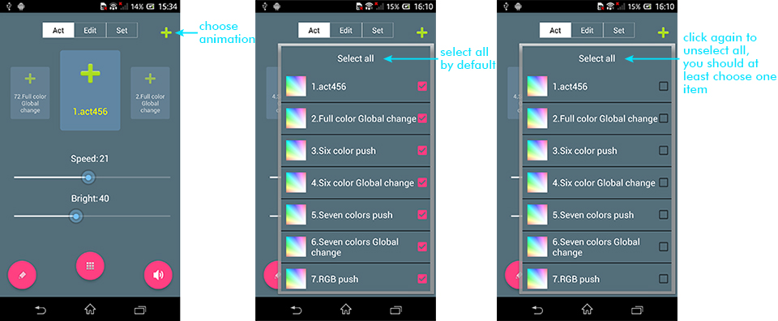

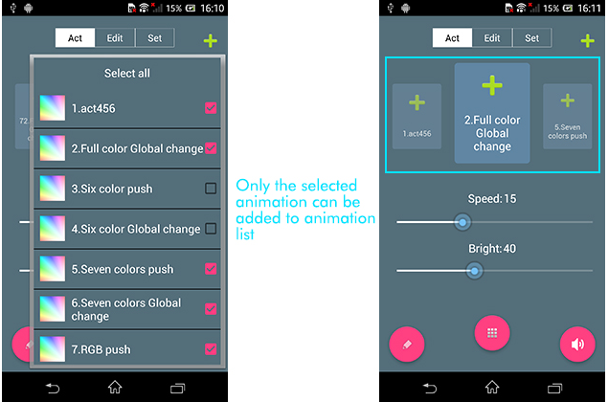

(2). Bridge H803WIFI to router

If you want to control one H803WIFI or multiple H803WIFIs with your phone while surfing Internet, the following steps are essential

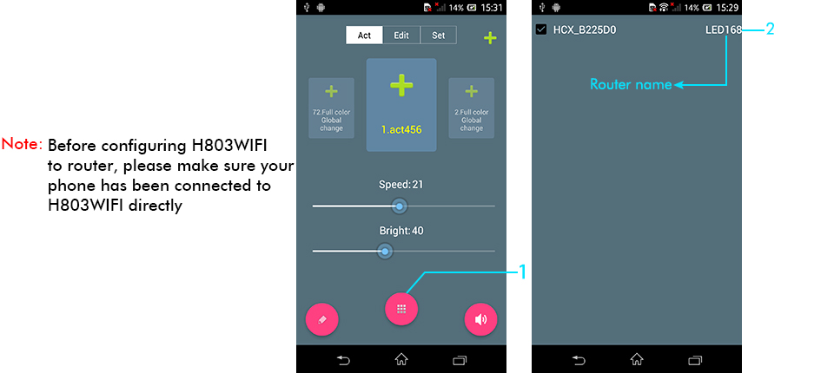

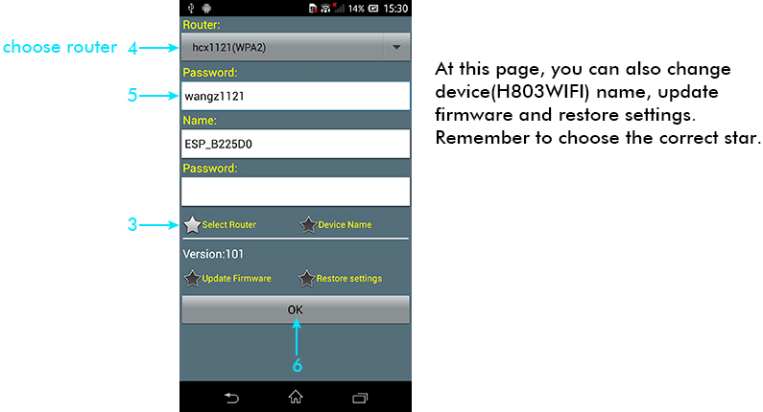

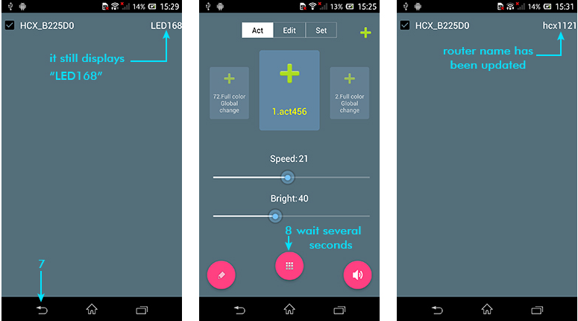

Now, you can use phone to control H803WIFI while surfing Internet

If you want to use phone to control many H803WIFIs, steps are basically the same:

Connect phone to H803WIFI directly first, then follow step1 to step8 above

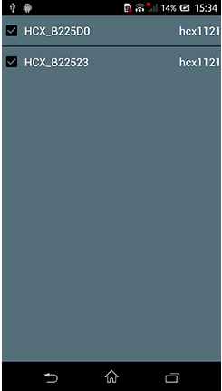

(3). Doodle

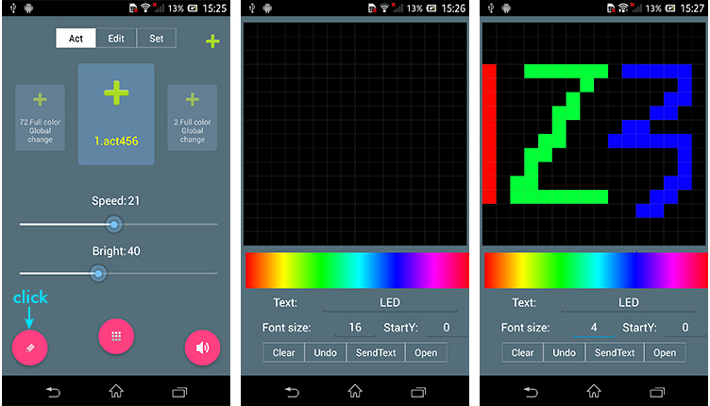

(4). Art-Net Remote Control

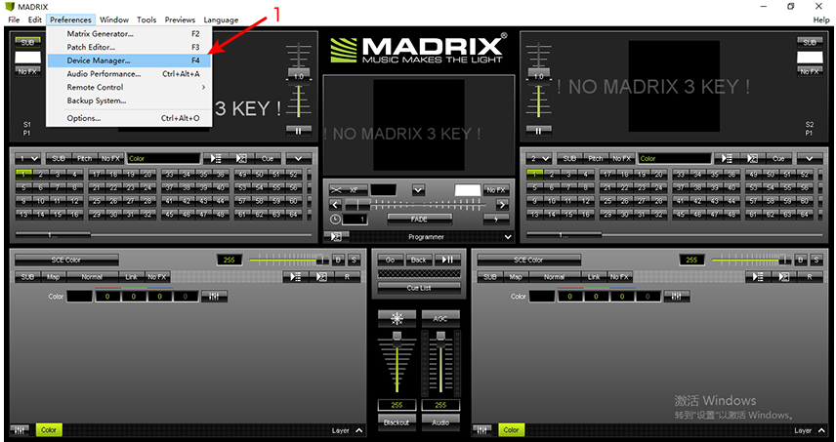

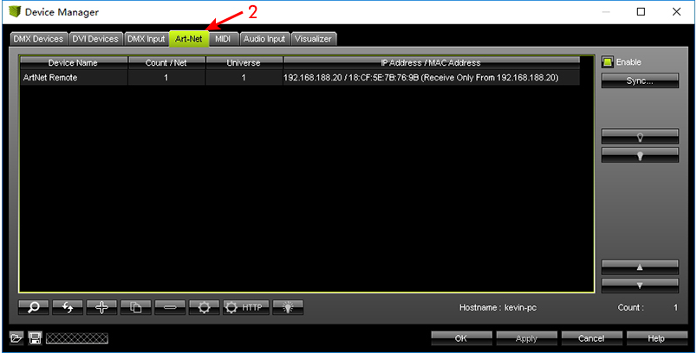

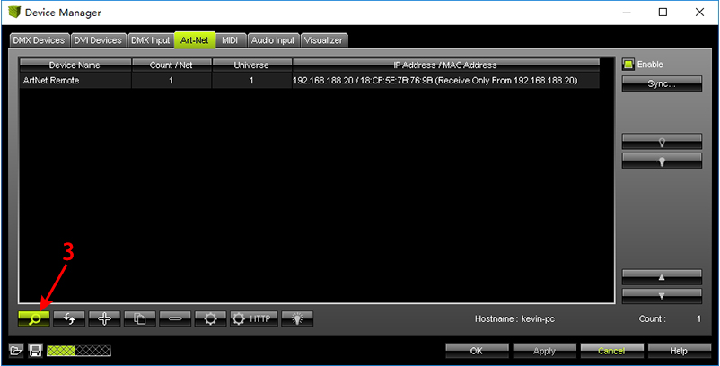

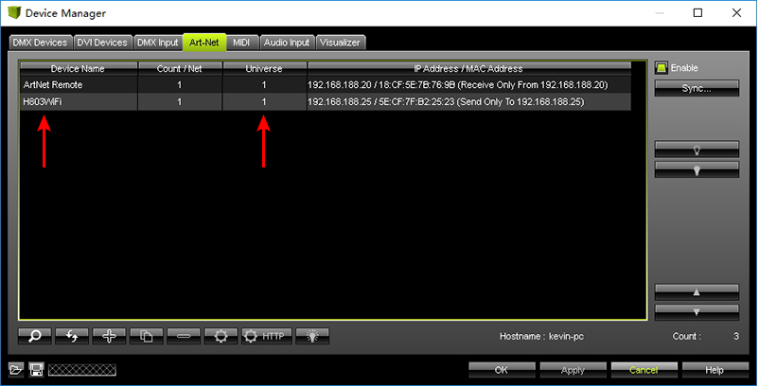

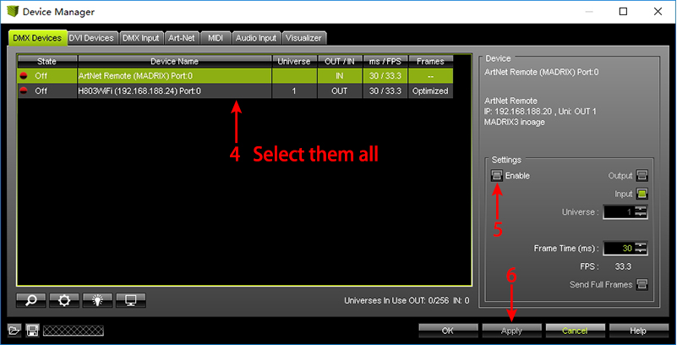

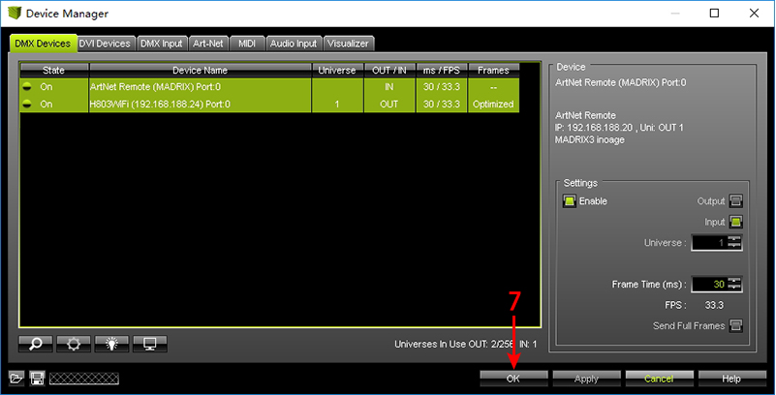
4. Specifications
Input Voltage | DC5-24V
Power Consumption | 0.6W
Drive Pixel Number | 2048
Weight | 40g
Working Temperature | -20C°--75C°
Size | 85mm x 45mm x 23mm

