XB-Z2 Master Controller

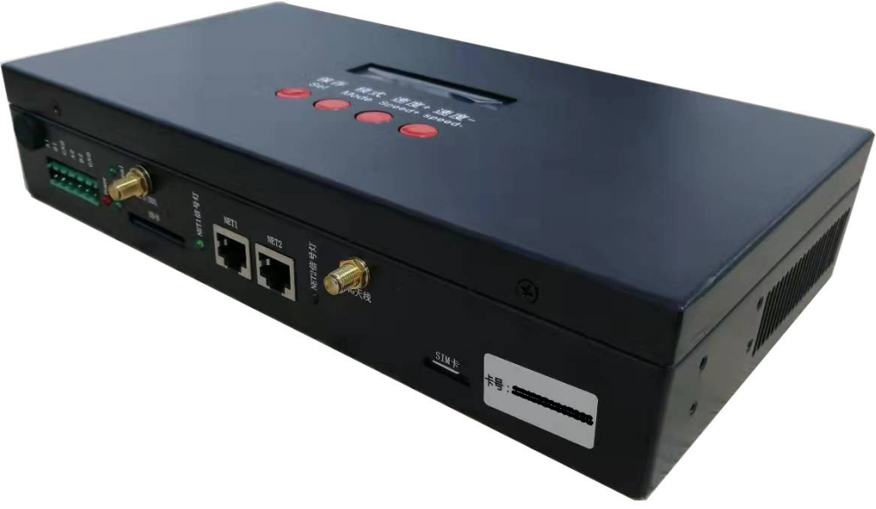
I. Features of master controller
Salient features:
1. Powerful performance, able to carry up to 100,000 pixels or 50 slave controllers
2. Integrate GPS/BDS satellite synchronization function and offline play function, easy to use and reliable.
3. Realize any timing and multi-level encryption function.
4. Single/master controller can load lamps independently or control lamps loaded by slave controllers.
General features:
1. The play content is stored in the SD card, which can store up to 32 effect files. The SD card capacity supports 4G-32GB, supporting single effect play, effect cyclic play, and effect acceleration and deceleration.
2. The master controller can automatically/manually the slave IDs. Multiple controllers can be set together or individually.
3. The controller adopts standard TCP/IP network protocol, and the signal transmission is more stable.
4. Support timing (holiday) play.
5. Support GPS/BDS dual mode-satellite timing synchronization.
6. It can be used offline with our T-700K/T-790/T-800K.
7. The IC controller for DMX lamps has its own address writing function; in addition, with our latest LedEdit-K software, you can set the one-key address writing function. Long press SET to write the address.
II. Support controller:
T-790 / T-700K
III. Controller image
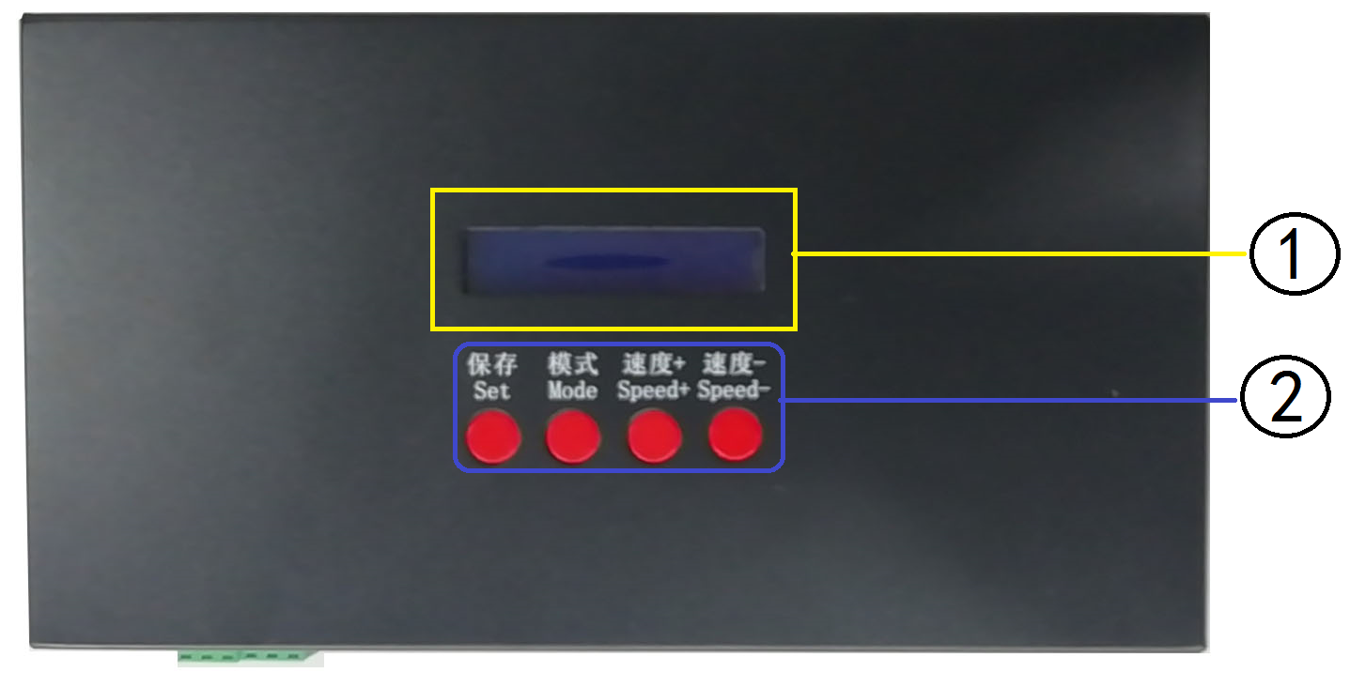
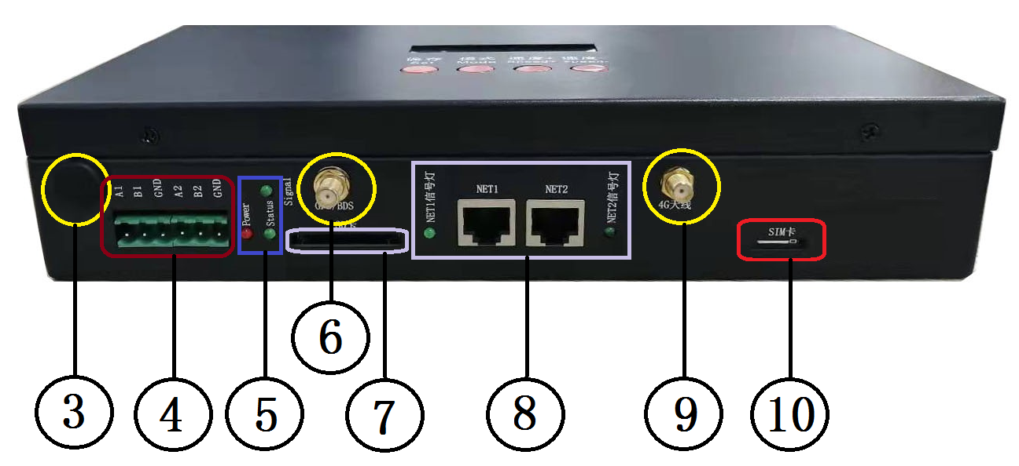
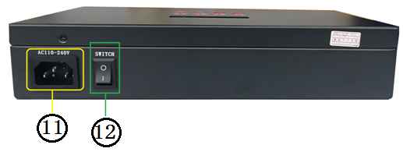
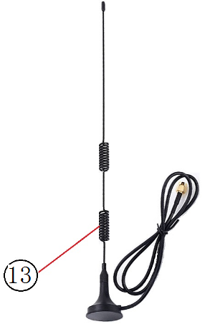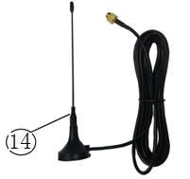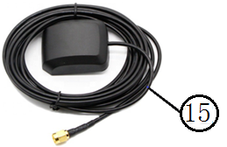

1. LCD screen | 2. Operation keys | 3. RF antenna interface (optional)
4. RS485 control interface | 5. Power/Status/Signal indicator | 6. GPS/BDS antenna interface (optional)
7. SD card slot | 8. NET signal indicator/NET port | 9. 4G RF antenna interface (optional)
10. SIM card slot (optional) | 11. Power interface | 12. Power switch
13. GPS antenna (optional) | 14. RF antenna (optional) | 15. GPS/BDS antenna (optional)
Note 1: The controller can select different options according to needs.
Note 2: The XB-Z2 standard version is not provided with GPS accessories, RF accessories, 4G accessories and interfaces.
The XB-Z2-GPS version is provided with GPS accessories and interfaces, but without RF accessories, 4G accessories and interfaces.
The XB-Z2-4G version is provided with 4G accessories and interfaces, but without RF accessories, GPS accessories and interfaces.
IV. Definition of indicators and keys
1. Indicator definition:
POWER | Power indicator | Always on after power on
STATUS | Status indicator | Off when normal
Signal | GPS/BDS signal indicator | Frequently flash when there is a GPS/BDS signal
NET1 signal indicator | NET1 cascade signal input | Frequently flash when there is a NET1 signal input
NET2 signal indicator | NET2 cascade signal output | Frequently flash when there is a NET2 signal

2. Port definition
Power supply | AC110-240V input
NET1 | Network signal interface | A1/B1 | Channel 1 485 interface
NET2 | Network signal interface | A2/B2 | Channel 2 485 interface
GPS/BDS antenna | GPS/BDS satellite antenna interface | SD card | SD card slot

3. Frame frequency of speed level:
Speed  Level | Frame frequency/sec | Speed  Level | Frame frequency/sec | Speed  Level | Frame frequency/sec | Speed  Level | Frame frequency/sec
1 | 4 frames | 5 | 8 frames | 9 | 14 frames | 13 | 23 frames
2 | 5 frames | 6 | 9 frames | 10 | 16 frames | 14 | 25 frames
3 | 6 frames | 7 | 10 frames | 11 | 18 frames | 15 | 27 frames
4 | 7 frames | 8 | 12 frames | 12 | 20 frames | 16 | 30 frames

4. Key functions
 | SET | MODE key | SPEED+ | SPEED-
Play Mode | / | / | / | /
Set ID Mode | ID start key | / | Digit+ | Digit-
Parameter Settings | Parameter setting/enter | Item selection | Parameter+ | Parameter-
Built-in play effect | Chip selection | Mode selection | Speed+ | Speed-
Remarks |  |  |  | Press "--" to power on and enter the numbering mode.
5. Display definition:
Display |  | Definition
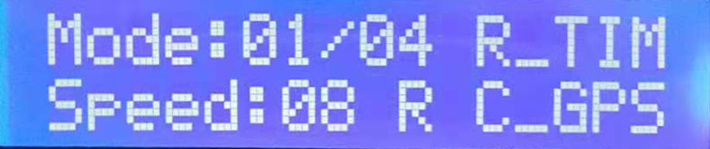 | Play Mode | MODE: Effect mode R-TIM: Remote timing play  Speed: Play speed R: 4G online C_GPS: GPS signal synchronous cyclic play
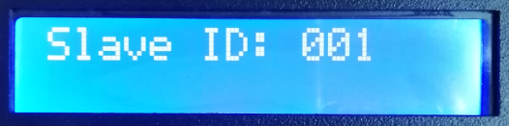 | Set ID Mode | Starting ID of slave controller: 001
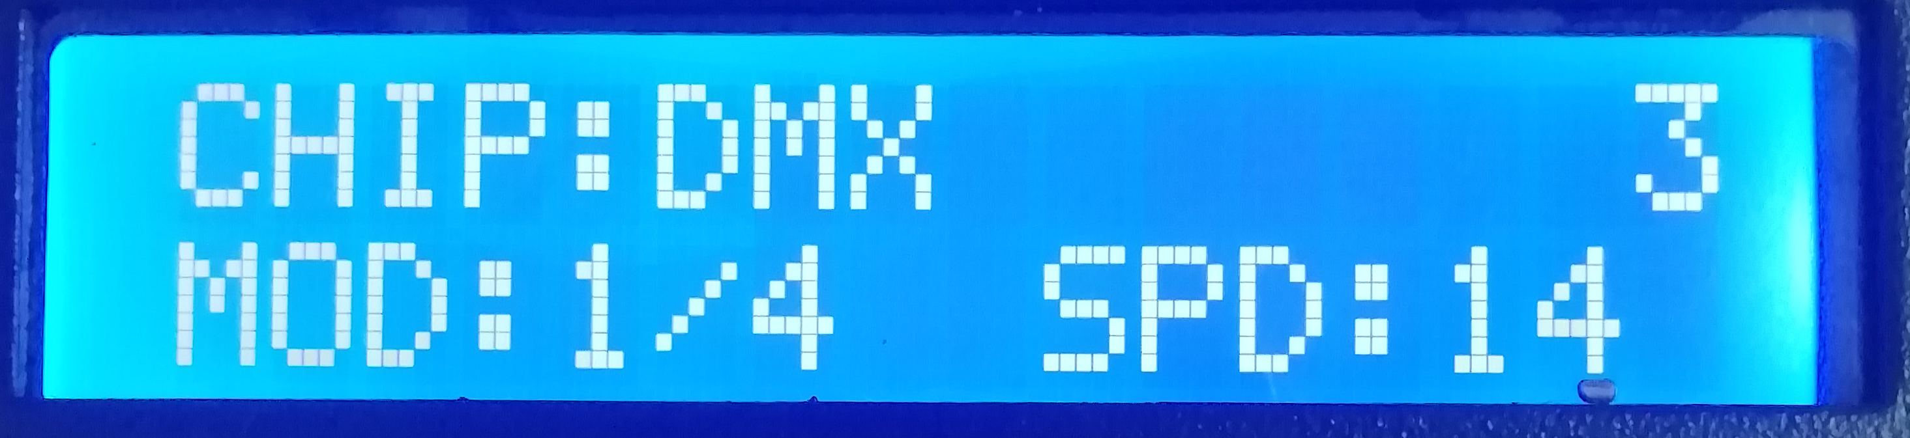 | Built-in effect  Play Mode | CHIP: Chip 3: Lamp channel  MOD: Built-in effect SPD: Play speed
V. Wiring diagram
- Single master controller control
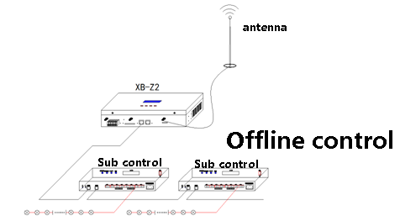
- Integrated online/offline control
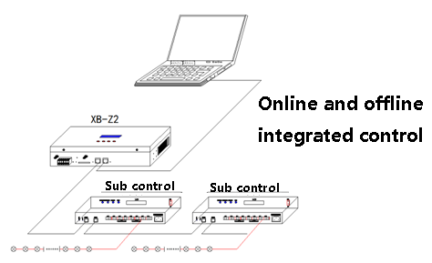
- GPS/BDS satellite signal synchronous control of multiple master controllers
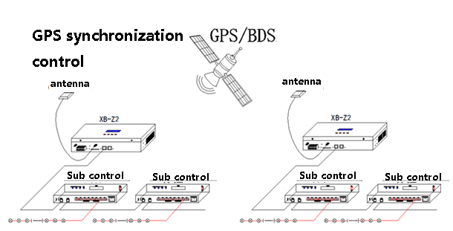

Note 1: The synchronous mode is GPS/BDS dual-mode satellite signal synchronization.
Note 2: When the controller adopts satellite for synchronization, the antenna of the satellite shall be placed outdoor.

VI. "SPEED-" key---Function description
Press and hold the "SPEED-" key on the master controller to display interface 1:
Set Slave ID Slave controller ID
Set GPS GPS/BDS satellite switch
Set TIME Time settings
Set Master ID Set master controller ID
Read UID Read UID number
Set 100-BASE Transmission rate settings
ModBus Address Master controller ID (third-party device control)
RF Channel Set RF frequency band
BT Switch Bluetooth switch
4G Switch 4G switch
Set Work Mode Set work mode
Set RF Set RF master controller/slave controller/relay
Console CH Set console channel
Single—Master Select single/master controller
Cycle SYNC Set GPS synchronous cyclic play
Note: For detailed description of each function of the controller, refer to "Function Set 1-*"

VII. "SET" key
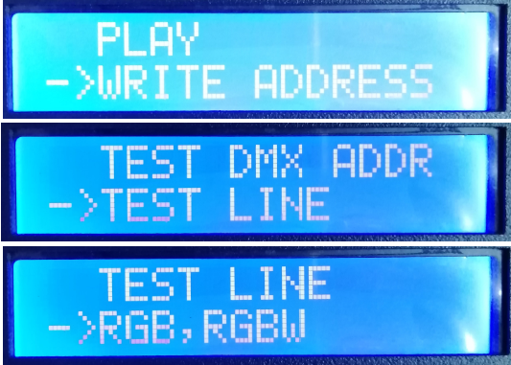
Press and hold the "SET" key on the master controller to display interface:
PLAY Built-in effect play
WRITIE ADDRESS Write address
TEST DMX ADDR Test DMX address
TEST LINE Test line
RGB,RGBW Select lamp channel
Note: For detailed description of each function of the controller, refer to "Function Set 2-*"

VIII. One-key address writing
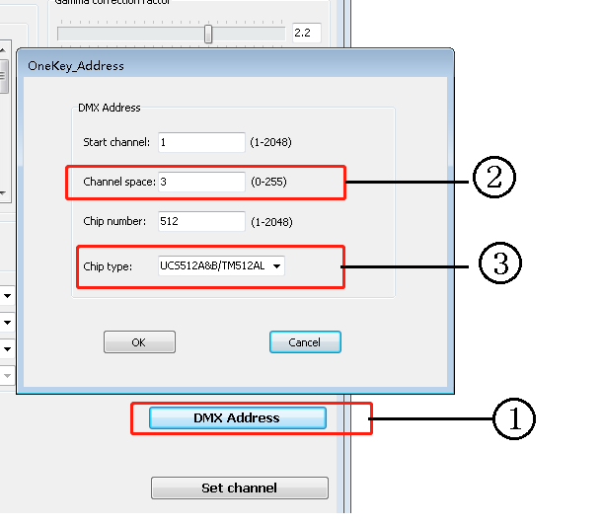
1. One-key address: (As shown in Figure 1)
When the software writes the program output, click the key to enter the one-key address writing interface
2. Interval channel input (As shown in Figure 2)
The interval channel is input according to the actual number of the lamp, and the number is the number of channels occupied by a DMX512 IC control lamp pixel point.
3. IC model selection (As shown in Figure 2)
Click the drop-down button to select the IC model corresponding to the DMX512 IC carried by the lamp.
4. Completing one-key address settings

After confirming that the settings are correct, click "SET" to complete the program output.
5. One-key code writing of controller
① Insert the SD card into the controller;
② Power on the controller;
③ Press and hold the "SET" key for 10s, and the controller will display "Writing Address" and then address testing interface after writing;
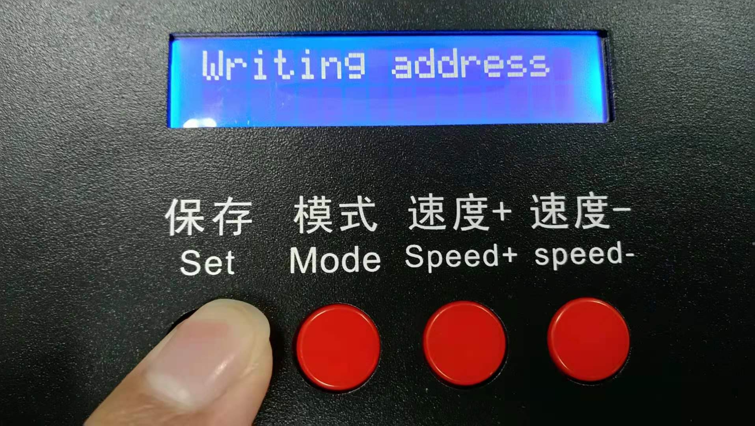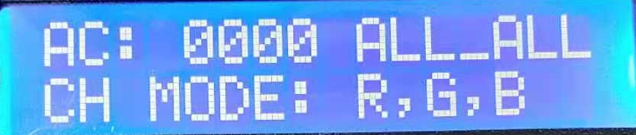
④ Press "MODE" key in the address testing interface to test the address. The "AC" address value increases automatically, and the "MC" address value can be manually adjusted by the "SPEED+"/"SPEED-" keys; and press the "Mode" key can switch between "Manual Test" and "Automatic Test".
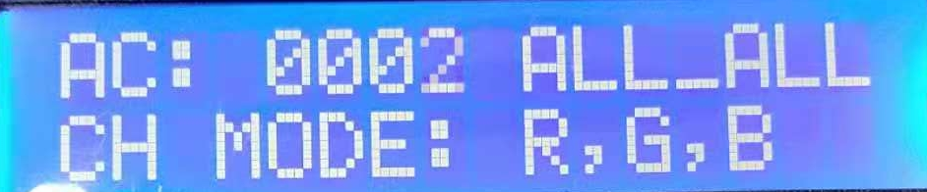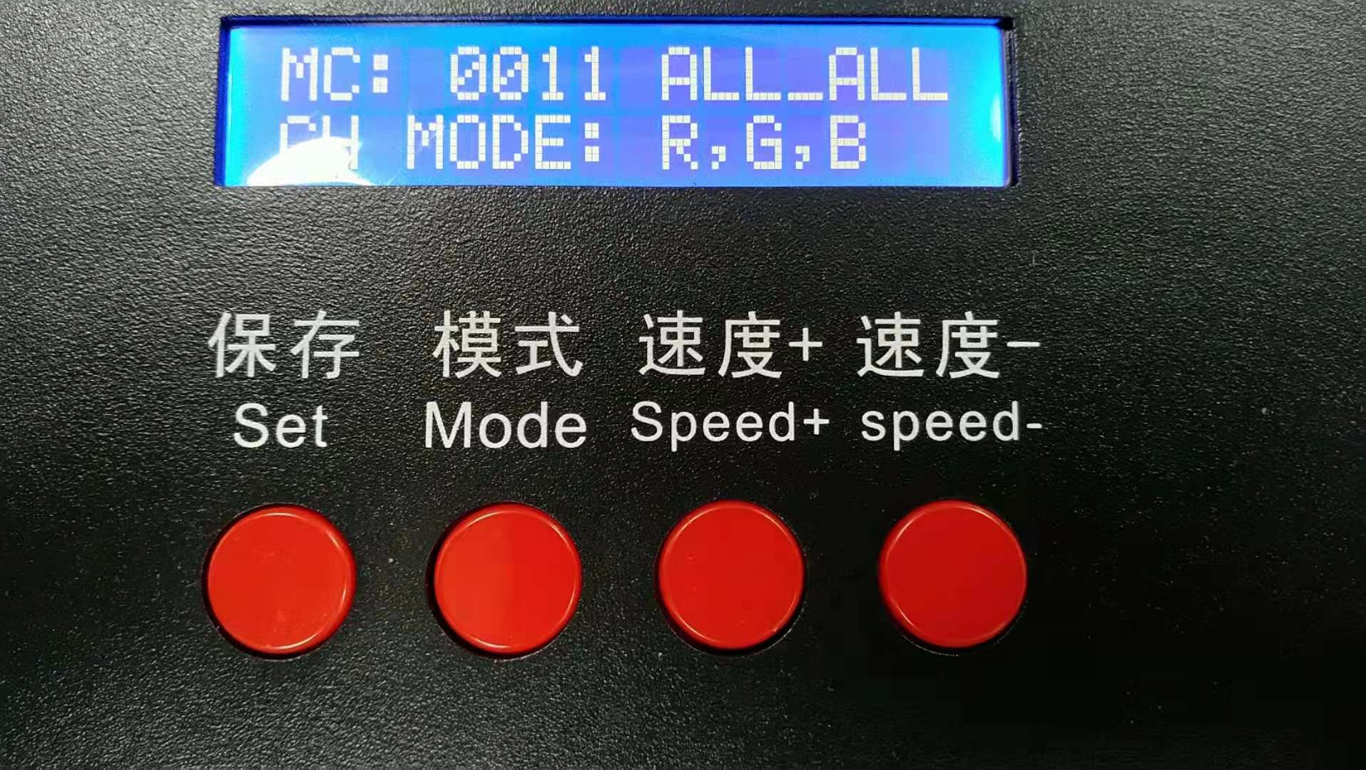
⑤ After completing address testing, press "SET" to exit the test mode and return to the play mode for normal operation.

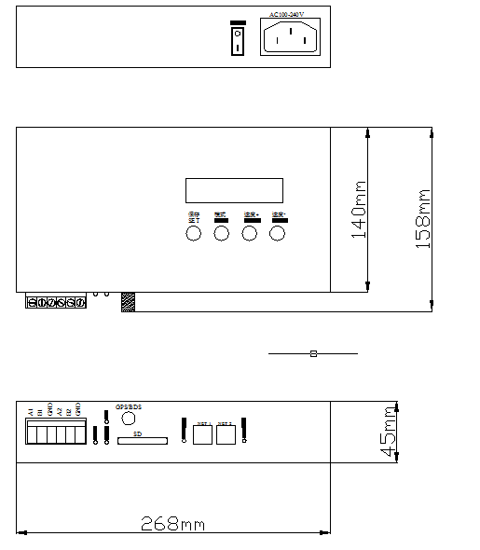
IX. Specific parameters
Memory card:
Type: SDHC card
Capacity: 4GB-32GB
Format: FAT32
Storage file: *.BIN
Physical parameters:
Operating temperature: -30℃～85℃
Operating power: AC110-240V
Power consumption: 5W
Weight: 2.5Kg
Data transmission interface: Network interface
Dimensions: L268mm * W158mm * H45mm

X. SD card formatting
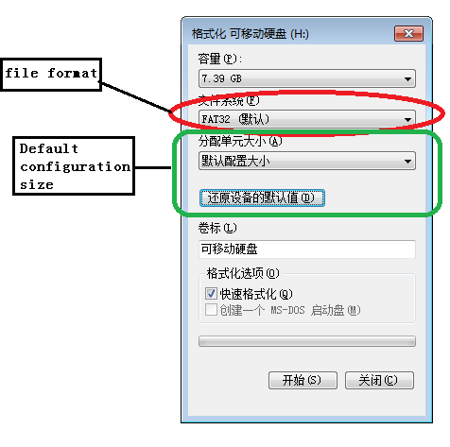
1. Before copying files to the SD card, the SD card must be first formatted. (Note that it must be formatted before each copying).
2. Format program
① SD Card Settings - "File System", "FAT32".
② SD Card Settings - "Allocation Unit Size", click the drop-down button to select "Default configuration size" or click "Restore default value of device".
③ Start formatting.
As shown in the Figure below:
3. The SD card cannot be hot swapped. It can only be plugged and removed after powering off the controller.

XI. Precautions:
1. The maximum cascade between each two nodes (between controllers, between controller and master controller, and between controller and computer) can be 100 meters using CAT5 or above network cable,
Beyond this distance, switches or optical fibers can be added for long-distance transmission.
2. The crimping mode of network cable is 568B direct connection.
